Basketball Shot Tracker — Lab Report: Own Footage, Tracker v2 and Detector v2
Oct 7, 2026

Abstract
Two changes, made between 2026-10-05 and 2026-10-07, raised the shot tracker's held-out end-to-end accuracy from 77.7% to 92.2% on 103 shots from public phone videos, and from 13.4% to 78.2% on 119 shots from our own iPhone footage. The first change, tracker v2, follows several candidate balls and waits for a ball that leaves the top of the frame. The second, detector v2, retrains the YOLOv8s ball/hoop detector on 5,324 extra phone frames of gyms with many people on court. Both test sets had been scored before, so these are re-tests of a frozen, untuned system rather than first looks; a clean headline number needs newly filmed, blind-labelled sessions. A speed sweep on development footage shows accuracy holds at 20 frames per second and, for landscape video, at 640 px input, which sets the target for an iPhone app.

1. Background and objectives
The project is a computer-vision system that watches a fixed phone camera and calls each basketball shot made or missed, with a planned real-time iPhone app. Before this work it scored 77.7% end-to-end (95% CI 69–85%) on 103 held-out shots from 16 public phone videos, but its detector had been trained only on about four mostly indoor, broadcast-style source videos.
Objectives:
- Measure the system on footage that matches the app's real use: our own iPhone sessions with several people on court.
- Find and fix the causes of failure on that footage without tuning on test data.
- Measure the effect honestly and check what the system needs to run on a phone.
Rules kept throughout: shots are labelled by hand before any tracker output is seen; data is split by whole video into dev (tune freely) and test (scored once, frozen code); every number states what it measures.

2. Timeline
The work ran over three days, newest first.
Date | Step | What happened
2026-10-07 | Speed sweep | Accuracy measured at 640 / 960 / 1280 px and 60 / 30 / 20 fps on dev footage
2026-10-07 | Frozen re-test | Current system scored once on both test sets: 92.2% public, 78.2% own
2026-10-07 | Settings check | An apparent tracker regression traced to a wrong image size; safeguards added
2026-10-07 | Dev comparison | New vs old detector on dev footage, same hoops and tracker
2026-10-06 to 07 | Detector v2 training | 12 epochs overnight on 8,347 images (first attempt crashed at 17:00, restarted 22:50, done 06:52)
2026-10-06 | Dataset build | Hooper v6 checked (licence, labels, box style) and merged with hotshot
2026-10-06 | Dataset search | Roboflow Universe candidates compared by licence, size, classes and camera view
2026-10-06 | First own-footage test | Tracker v2 + old detector scored once on sessions 2–4: 37.8%
2026-10-06 | Tracker v2 | Diagnosis on dev session 1, then three tracker changes
2026-10-06 | Labelling | 162 shots labelled blind with made/missed and shot type; sessions 1 and 2 trimmed
2026-10-06 | Setup | Videos imported, split fixed, hoop boxes set, tools generalised for new footage
2026-10-05 | Filming | Four indoor sessions recorded between 20:01 and 20:15

3. Materials
Three kinds of data were used, never mixed: evaluation footage (scored against hand labels) and two training datasets (for the detector).

3.1 Own iPhone sessions (new)
Four indoor sessions, iPhone 11 on a tripod on the baseline beside the hoop, facing the court; 1920×1080, 59.94 fps, H.264; three people taking turns. The split was fixed before any tracker output was seen.
Session | Split | Length | Shots labelled (made) | FT / mid / 3PT | Notes
1 | Dev | 3:16 | 43 (16) | 11 / 14 / 18 | Two balls in play at times; first 27 s (form shooting) trimmed
2 | Test | 4:11 | 41 (5) | 10 / 15 / 16 | First 35 s (warm-up) trimmed
3 | Test | 3:37 | 39 (21) | 10 / 14 / 15
4 | Test | 3:40 | 39 (11) | 10 / 15 / 14
Labelling: one row per shot (time the ball reaches the hoop, made or missed, shot type), made with a key-press tool that never shows predictions. Predictions match a label within ±1.5 s. Trims were re-encoded at near-lossless quality and checked frame by frame (first frame at 27.01 s and 35.00 s of the originals).

3.2 Public phone videos (existing)
16 portrait videos (1080×1920, ~60 fps; indoor/outdoor, ground/tripod camera, free throws and threes), 201 hand-labelled shots: 8 dev videos (98 shots) and 8 test videos (103 shots). No licence, so used locally only.

3.3 Detector training data
Dataset | Licence | Images used | Classes used | Notes
hotshot v5 (Roboflow) | CC BY 4.0 | 3,023 train / 190 val | ball, hoop (rim + net) | The original training set
Basketball Detection v6 by Hooper (Roboflow) | CC BY 4.0 | 5,324 train / 690 val | ball, rim_only | Phone video of gyms with many people; every 8th of 48,110 frames; validation = whole 2,000-frame blocks
Hooper's hoop boxes cover the rim only (about 4× wider than tall), unlike hotshot's rim-and-net boxes, so they became a separate class the tracker ignores; its boxes around people were dropped. No frames from any evaluation footage were used for training.

4. Methods
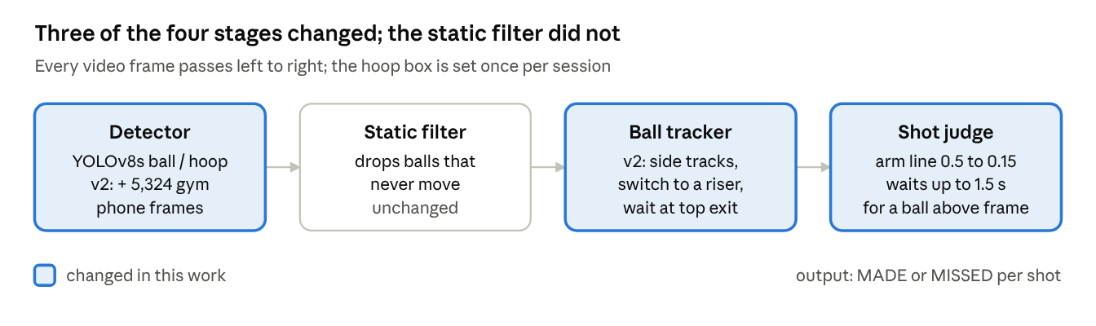
pipeline stages and what changed, 2026-10-05 to 07
The detector, the ball tracker and the shot judge changed; each change was chosen on dev footage only.

4.1 Tools and environment
Item | Used for
PC: Windows 10, NVIDIA GTX 1660 SUPER (6 GB) | Training and running everything
iPhone 11 on a tripod | Filming (1080p, 60 fps, landscape)
Python 3.10, PyTorch 2.14 (CUDA 12.6), Ultralytics 8.4 (YOLOv8s) | Detector training and inference
OpenCV, NumPy | Video reading, drawing, geometry
imageio-ffmpeg | Frame-accurate trimming of sessions 1 and 2
Roboflow Universe | Finding and downloading the extra training dataset
pytest, GitHub Actions | 88 automated tests on every push
Project scripts | label_shots.py (blind labelling), mark_hoop.py, run_eval_videos.py, evaluate.py, compare_runs.py (side-by-side scoring), debug_video.py + replay_eval.py (fast replays on dev), build_combined_dataset.py, train_detector.py

4.2 Tracker v2
Diagnosis on dev session 1 found three failure causes, each with one fix:
- Fake balls on people. The detector fired on heads, calf sleeves and hands at 0.6–0.8 confidence, and the single-target tracker locked onto them. Fix: other detections are kept as short side tracks; one that rises fast for 4 frames (at least 12 ball-widths per second, mostly upward) takes over from a main track moving at under half that speed.
- Ball lost near the apex. High arcs left the top of the frame or vanished against ceiling lights for about 0.5 s, and the tracker restarted on a leg. Fix: when the track was heading out of the top, tracker and shot judge wait up to 1.5 s for the ball to reappear near where it left.
- Arm line too high. A low camera near the hoop makes the hoop box tall, so many arcs never rose 0.5 hoop-heights above the rim. Fix: 0.15 hoop-heights.

4.3 Detector v2
Fine-tuned from the original detector on the combined dataset (8,347 training images, 880 validation): 12 epochs, image size 960 px, batch size 2, early stopping patience 5, about 47 minutes per epoch. Batch size 4 needed about 8 GB on the 6 GB card and the first attempt ended in a graphics-driver reset after 15 minutes; batch size 2 fit in 5.8 GB.

4.4 Measurement safeguards added
- Label files and code are fingerprinted (SHA-256) and copied before any test run.
- Runs record their settings (weights, image size, frame step); compare_runs.py warns when compared runs differ.
- Image size defaults to 1280 px for portrait video and 960 px for landscape.

5. Results
The current system (detector v2 + tracker v2) scores 92.2% on the public test videos and 78.2% on our own test sessions, both clear gains with non-overlapping 95% intervals. End-to-end accuracy counts a shot as right only if it is found and called correctly.

5.1 Frozen re-test: public test videos (8 videos, 103 shots)
Settings matched the original run: 1280 px, every 2nd frame, the same hoop boxes.
Metric | Original (2026-10-02) | Current system
End-to-end accuracy (95% CI) | 77.7% (69–85%) | 92.2% (85–96%)
Shots found (recall) | 82.5% | 96.1%
Precision (found shots that were real) | 98.8% | 99.0%
Made/missed correct on found shots | 94.1% | 96.0%
Outdoor / indoor | 66.7% / 88.5% | 90.2% / 94.2%
Free throws / threes | 84.5% / 68.9% | 89.7% / 95.6%
The old weak spot, video 2 (outdoor, camera on the ground, threes), went from 3 to 11 of 12 shots right.

5.2 Frozen re-test: own sessions 2–4 (119 shots)
Settings: 960 px, every frame, hoop boxes set once per session.
Metric | Old detector + original tracker | Old detector + tracker v2 (2026-10-06) | Current system
End-to-end accuracy (95% CI) | 13.4% (8–21%) | 37.8% (30–47%) | 78.2% (70–85%)
Shots found (recall) | 18.5% | 44.5% | 86.6%
Precision | 95.7% | 100% | 98.1%
Made/missed correct on found shots | 72.7% | 84.9% | 90.3%
Free throws / mid-range / threes | — | 60.0% / 38.6% / 22.2% | 76.7% / 70.5% / 86.7%
By session, the current system found 27/41, 37/39 and 39/39 shots; session 2 holds most of the remaining misses. Among found shots, 5 makes were called misses and 5 misses called makes.

5.3 Which tracker change matters (dev, replay)
Each tracker-v2 change switched off in turn, with detector v2 at 960 px.
Tracker | Old dev videos (98 shots) | Dev session 1 (43 shots)
Original | 89.8% | 62.8%
Tracker v2, all changes | 89.8% | 86.0%
v2 without switching | 89.8% | 74.4%
v2 without the top-exit wait | 89.8% | 76.7%
v2 without the lower arm line | 89.8% | 79.1%
On side-on footage the changes alter nothing (the same shots right and wrong); on our footage each adds 7–12 points.

5.4 Detector v2 training
Validation on 880 held-out images after 12 epochs: precision 0.871, recall 0.823, mAP50 0.851 (ball 0.747, hoop 0.931, rim_only 0.876), mAP50-95 0.433. Before training, the original detector found only 53 of 242 labelled balls in a random sample of 300 Hooper frames at 0.5 confidence.

6. Speed vs accuracy for a phone app
The phone can run the detector at 20 frames per second and, for landscape video, at 640 px with little or no loss: our footage stays at 84–88% at every setting tested.
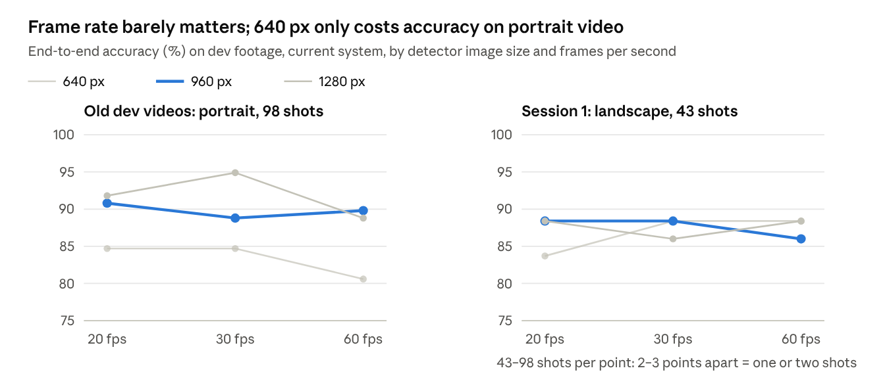
replays of every-frame detections, dev footage only, 2026-10-07
Detector time on the PC graphics card for one 1920×1080 frame: 12.7 ms at 640 px, 19.4 ms at 960 px, 31.6 ms at 1280 px. Lower frame rates were simulated by skipping frames in the every-frame detections, which gives the same result as a live run at that rate.
Recommended app setting: landscape filming, 960 px at 20–30 fps; fall back to 640 px at 30 fps if the iPhone 11 cannot keep up. Speed on the iPhone itself is not yet measured.

7. Discussion and limitations
Most of the gain came from the data, not the logic: training data with people on court cut the false "balls" that misled the tracker, and recall on our footage doubled (44.5% to 86.6%). The tracker changes mattered most while the detector was still weak, and cost nothing on side-on footage.

7.1 Threats to validity
- Re-used test sets. Both test sets had been scored before; the low first own-footage score (37.8%) motivated the detector retraining. Nothing was tuned on them and the system was frozen first, but these are re-tests, not first looks.
- One gym, one evening. All four own sessions come from the same gym, camera spot and three people, so 78.2% says little about other courts.
- Small samples. 103 and 119 test shots give 95% intervals about ±7–8 points; differences of 2–3 points on dev are one or two shots.
- Uneven sessions. Session 2 alone accounts for 14 of the 16 shots not found on our footage.
- Not yet on a phone. All numbers come from Python on a PC; the app must convert the detector and port the tracking logic.

7.2 Mistakes caught along the way
Date | What went wrong | How it was caught | Fix
2026-10-07 | Old portrait videos run at 960 px instead of the original 1280 px, which looked like a 5-point tracker regression | Replays at matching settings showed both trackers scoring the same | Image size chosen by video shape; settings saved per run; mismatch warning
2026-10-06 | First training run used about 8 GB on a 6 GB card and ended in a graphics-driver reset after 15 minutes | Windows event log at the moment the process died | Batch size 2 (5.8 GB), same time per epoch
2026-10-06 | Evaluator would have attached old video N's setup notes to new session N | Code review while generalising the scripts | Setup files looked up next to each label folder
2026-10-06 | Automatic hoop finding picked the far-wall hoop in 3 of 4 sessions | Visual check of each hoop box | Hoop set once per session (the app's planned tap-the-hoop step)

8. Conclusion and next steps
Retraining the detector on licensed phone footage with people on court, plus three targeted tracker changes, took the system from 77.7% to 92.2% on public test videos and from 13.4% to 78.2% on our own footage, at settings a phone can plausibly run. The open questions are a clean first-look test number and real speed on the iPhone 11.
- ☐ Film 2–3 fresh test sessions, ideally a different gym or camera spot, split decided before filming; label blind; score once
- ☐ Study missed shots like session 2's on new dev footage (session 2 itself is test data and stays untouched)
- ☐ Convert the detector to Apple's Core ML format (in Google Colab, since the converter does not run on Windows) and time it on the iPhone 11
- ☐ Port the tracker and shot judge to the app, checked against the Python version on the same detections

References and credits
- Basketball Detection v6 by the Roboflow user "Hooper", CC BY 4.0: extra detector training data.
- basketball detection v5 by the Roboflow user "hotshot", CC BY 4.0: original detector training data.
- gbikushev/Basketball-Score-Detection-ComputerVision: source of the 16 public evaluation videos (no licence; used locally only, not redistributed).
- Ultralytics YOLO (AGPL-3.0), PyTorch, OpenCV, NumPy, imageio-ffmpeg, pytest.
- chonyy/AI-basketball-analysis: prior work studied for the problem; no code used.
- Project repository: NathanielRecto/Basketball-Shot-Tracker.

